BAPTIST CHURCH

***June***

pe02110_June

Nursery Schedule

1 0-2 Year Old….…Ashley Smothermon

3-K Year Olds Terri Edwards

Helper

8…0-2 Year Olds Otisann McManus

3-K Year Olds Kristi Suchomel

Helper

15 0-2 Year Olds

3-K Year Olds Becky Yount

Helper Lindsey Knobloch

22 0-2 Year Olds Shirley Marecle

3-K Years Theresa Schane

Helper

29 0-2 Year Olds Jana Moore

3-K Years Paula Knobloch

Helper

SPECIAL NOTE: MEALS ON WEDNESDAY EVENING BEFORE SERVICES ARE BEING DISCONTINUED FOR THE SUMMER MONTHS

**Weekly Service & Activity Schedule:**

SUNDAY

Sunday School 9:45 a.m.

Morning Worship Services 11:00 a.m.

Evening Worship Services 6:00 p.m.

WEDNESDAY

Youth Worship 7:00 p.m.

Wednesday Services 6:45 p.m.

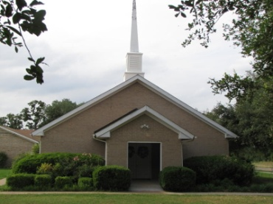

1662 CR 305

McDade, TX 78650

Phone: (512) 273-2743

Email: [KnobbsSpringsBaptist@gmail.com](mailto:KnobbsSpringsBaptist@gmail.com)



*KnobbsSpringsBC.com*

Interim Pastor

Brother Dwight Reagan

Home: 512-247-6448 / Cell: 512-964-1433

Email: dwlReagan@aol.com

**Other Contacts**

*Cleyon Davis – Treasurer*

(512) 856-2524

*Shirley Marecle – Temporary Office Manager*

*KnobbsSpringsBaptist@gmail.com*

**June Ushers**

Kenny Merrell, David Condron.

Sam McManus Mickey Stanford

**June Hostesses**

Pam Daniel, Mickey Stanford,

Terri Edwards, Evelyn Robinson

WHAT’S GOING ON?





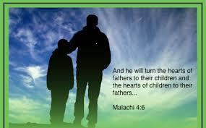



Congratulations

Graduates!

Rachel Cook

Alexis Fisher

Morgan Halvorson

Cody Ruthven

Hunter Wilson

Clyde Bell from Joelton, TN will be our Special Guest Singer during morning worship June 8th



June

1 Kids in Action

7-12 MPACT Mission Trip

8 Graduation Banquet

8 Business Meeting

12 Adult Fellowship – 10 am

15 Father’s Day

22 Wedding Shower –

Wesley & Holly Seigmund

26 Adult Fellowship – 10 am

29 Birthdays and Anniversaries



July

4 Independence Day

6 Kids in Action

6 Lord’s Supper

10 Adult Fellowship-10 am

13 Business Meeting

21-25 Journey Youth Camp

24 Adult Fellowship-10 am

27 Birthdays and Anniversaries

**You’ve Gotta Hand It to Those Muslims**

Those Islamic terrorists mean business. They fly airplanes into buildings knowing they will die – and many others with them. They strap bombs to their chests, ride motor bikes into crowded squares and blow themselves up. They set off home made explosives at marathons. They bomb embassies and naval vessels. They burn young men to death in school dormitories and kidnap school girls 300 at a time. They are vicious, murderous and gladly self-sacrificing. They exhibit radical commitment to an unworthy cause.

But you must give them credit. They are totally committed to

their beliefs.

Compare their commitment to your’s/mine. Will we go

anywhere, do anything, pay any price at any time that God directs?

Is our surrender as thorough, as deep, as irrevocable as their’s.

Now hold on, Preacher! Where does this crazy idea come from?

Well, it comes from Jesus. “If anyone comes to me and does not hate his father and mother, his wife and children, his brothers and sisters – yes, **even his own life** – he cannot be my disciple. And anyone who **does not carry his cross and follow me** cannot be my disciple.” (Luke 26-27) *Lord, surely, You were joking!*

Uh, oh! He said it again! “Anyone who loves his father or mother more than me is not worthy of me; anyone who loves his son or daughter more than me is not worthy of me; and anyone **who does not take his cross and follow me is not worthy of me.** Whoever finds his life will lose it, and **whoever loses his life for my sake will find it.”** (Matthew 10:37-39) *Aw, Lord, You really don’t mean it, do You?*

Oh, and it comes from Brother Paul, too. “I only know that in every city The Holy Spirit warns me that prison and hardships are facing me. However, **I consider my life worth nothing to me, if only I may finish my race and complete the task the Lord Jesus has given me** - the task of testifying to the gospel of God’s grace.” (Acts 20:23-24)

Now hold on, saints. Let’s not get too radical! Let’s not overdo it!

Brother Dwight

Non-Profit Organization

U. S. Postage Paid

Permit # 1

McDade, Texas

Non-Profit Organization

U. S. Postage Paid

Permit # 1

McDade, Texas



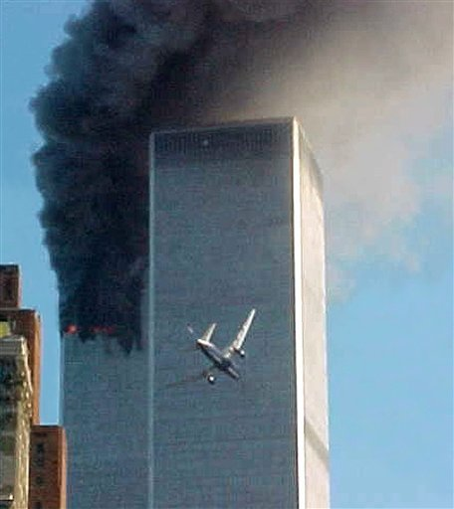







Knobbs Springs Baptist Church

1662 CR 305

McDade, TX 78650

